Nailboard - Can you get 10 nails on top of one nail in a small board?

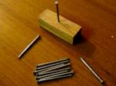
This seems very difficult, nearly impossible. This problem is an image of Gods family: you as a team in mission (Ef 2:19-22), facing huge obstacles…. but the solution is quite simple:

Foundation: Lay down 1 nail just somewhere beside the board. This is an illustration of 1 Cor 3:11 For other foundation can no man lay than that is laid, which is Jesus Christ.
1 Pet 2:6 Behold, I lay in Sion a chief corner stone, elect, precious: and he that believeth on him shall not be confounded.
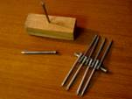
Keep 1 nail separate and the other 8 nails alternating 1 by 1 with their heads together on that foundational nail. This is an image of true love and respect and acceptance among Christians. Not 1 nail in particular is important… they all have a place on the foundation and are part of the work of God. This is also the way that outsiders recognize the Spirit of God in the team: Love and unity. So have the heads together in love and acceptance.

John 13:35 By this shall all men know that ye are my disciples, if ye have love one to another.
John 17: 21 That they all may be one; as thou, Father, art in me, and I in thee, that they also may be one in us: that the world may believe that thou hast sent me.
Col 3:13 Forbearing one another, and forgiving one another, if any man have a quarrel against any: even as Christ forgave you, so also do ye.

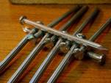
But one ingredient is still missing. Despite the good intentions these 8 nails will fall apart as soon as they are moved. That is the case if each nail/person is only focused on his own interests or importance. They need a head “Jesus Christ” to listen to, to go for… If Jesus is Foundation and Head, Alfa and Omega you have a solid construction!

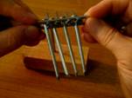
So put the separate nail on top of the eight nails to keep them together so that the eight nails are held together between the base-nail and top-nail, Foundation and Head. If the nails are held together “in Christ” the miracle happens: take the whole bunch and put it on top of that one nail in the board and they will be stable.

Ef 2:20 … Jesus Christ himself being the chief corner stone;21 In whom all the building fitly framed together groweth unto an holy temple in the Lord: 22 In whom ye also are builded together for an habitation of God through the Spirit.

Col 2:19 holding the Head, from which all the body by joints and bands having nourishment ministered, and knit together, increaseth with the increase of God.
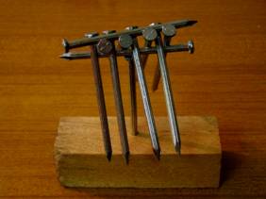
Hebr 12:1-3 1 Wherefore seeing we also are compassed about with so great a cloud of witnesses, let us lay aside every weight, and the sin which doth so easily beset us, and let us run with patience the race that is set before us,2 Looking unto Jesus the author and finisher of our faith; who for the joy that was set before him endured the cross, despising the shame, and is set down at the right hand of the throne of God.3 For consider him that endured such contradiction of sinners against himself, lest ye be wearied and faint in your minds.

